Unit 4: Solving Quadratics (Notes 4.1) Name:__________________

This unit will consist of three separate tests:
- Test over Solving
Solving methods included in this portion of the unit:
  - Factoring
  - Square Root
  - Completing the Square
  - Quadratic Formula
- Test over Graphing
- Test over Writing Equations and Quadratic Inequalities

Solving Notes 4.1: Solving by Factoring
Definition of Quadratic Equation:

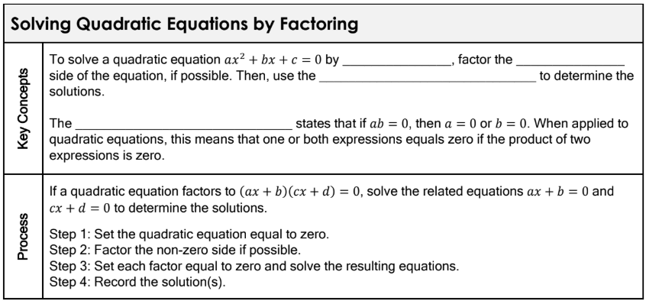

Examples: Find all the real solutions of the quadratic equation by factoring.

1.$x^{2}-10x=28-7x$ 2. $2x^{2}+13x+21=0$

3. $5x^{2}+14x=3$ 4. $x^{2}+8x-48=0$

Solving Notes 4.1: Solving by Square Roots
What is a radical?

What does it mean?
It means we are “taking a root” of the value inside the radical.
- $\sqrt{4}$ reads “the square root of 4”

Why is it important to me?
- We can solve an equation using square roots
- These will show up sometimes when we “Complete the Square” to solve a quadratic equation
- AND they show up in the Quadratic Formula.

Simplifying Perfect Square Roots

$\sqrt{25}$ $\sqrt{81}$ $\sqrt{64}$ $\sqrt{\frac{1}{16}}$ $\sqrt{\frac{9}{100}}$ $\sqrt{\frac{25}{49}}$

Simplifying NON-Perfect Square Roots

$\sqrt{56}$ $\sqrt{24}$ $\sqrt{63}$ $\sqrt{48}$ $\sqrt{175}$ $\sqrt{90}$

